Edson John Gomes
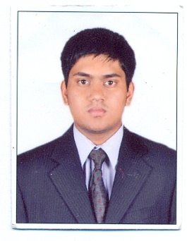 | Address : House No 775/71, Borim - Ponda , Goa India, 403401  Mobile No : 9049812771 / 9545675122  DOB : 20th Jan, 1994  Nationality : Indian  Email id : edskkgomes@gmail.com

CAREER OBJECTIVES
To seek a responsible position and build my career under reputed organization that will help me grow in professional skills and contribute through the skills acquired.

Education:
- Completed Bachelor of Technology Degree in Mechanical Engineering from College of Engineering Pune, 2011-2015
- Passed in CBSE AISSCE Board Exam from Carmel School Kuwait, 2011
- Passed in CBSE AISSE Board Exam from Carmel School Kuwait, 2009

Projects Completed:
- Wind Turbine Design for household purpose with analysis of NACA 0010 air foil.
- Automatic Gear Transmission for self-propelling bicycles.
- Design of a single hole punching press.

Vocational Training:
- Carried out at Chowgule and Co. Pvt. Ltd India : Fabrication and assembly of a 4450 DWT Multi-Purpose General Cargo vessel. Different welding techniques and Non-Destructive tests. Various mechanical systems aboard a coast liner.

- Carried out at United Oil Projects Kuwait: Sync of hot oil burner, chilling unit, cooling towers, reactors and thinning tanks within a chemical plant. Also viewed different types of compressors, condensers, pumps, valves etc.

- Attended 3 days training as Technical Service Advisor at Al - Sayer Group (Toyota), Kuwait functioning as a mediator between customers and technicians. To inspect vehicle and note the fault and maintenance to be carried out.

PROFESSIONAL EXPERIENCE:

- Worked as Mechanical Engineer Trainee for period of six months from Aug 2015 – Jan 2016 for
IEC Global Services LLP, India

WORKING EXPERIENCE:

- Presently working at Mormugao Port Trust – Goa from April 2016 until now as Graduate Trainee Engineer
Hobbies :
- Playing Music, Playing Football and Singing

Extra-Curricular Activities:
- Played for a band in school as well as competed in “Battle of Bands” on numerous occasions.
- Played football for a minor club as well as represented school in inter-school football competitions
- Coordinated in “Bull Run” in Mind Spark 2013
- Underwent “EAGLE” Program conducted by Hermitage

Computer Skills:
- C ++ and C Language
- Auto-Cad completed at Indo German Training Centre Pune
- Catia, Solid works & Creo
- Microsoft Office, Microsoft Excel, PowerPoint, Outlook 2010

Known Languages:
- Fluent in English, Hindi

